REVIEW OF THE DEVELOPMENT OF SHS POVERTY ESTIMATES FOR LOCAL AUTHORITIES IN SCOTLAND.

Summary
Poverty estimates for each local authority in Scotland were published for the first time in August 2010. Following this publication there were some concerns raised as to the validity of the estimates, particularly relating to their relationship with other proxy measures. This report re-evaluates and investigates the methods used and the underlying Scottish Household Survey (SHS) income data to assess if they can support the estimation of poverty at Local Authority level. The main methodological issue was the use of an imputation process to impute income estimates for the additional adults within a household (in multi-adult households) for which the SHS does not currently capture. Main points:
- The original feasibility study published in 2009 concluded that is feasible to impute reasonable approximations of income for other adults in the SHS to produce estimates of household income that will be robust at the national and local authority level.
- Office for National Statistics (ONS) implementation work concluded that “the quality level of the estimates is in the most part drawn from the direct estimate portion, with the imputation having a relatively minor effect. In this way the quality is comparable to that of other similar proportion local authority SHS estimates”.
- The imputation process works as expected in that it has the biggest impact on larger households. The impact across LAs also seems reasonable when you take account of the differences in the distribution of household types.
- A considerable level of income imputation has already taken place at the original SHS data processing stage (with around one half of records having some element of income imputed due to missing data), which suggests there are limitations to analysis that should be attempted on income even at a Scotland level.
- The ‘other adult’ imputation is completely separate to the ‘data processing’ imputation as it draws on information from the FRS.
- There are many reasons to suggest that we should expect differences between poverty and benefit-based proxies at local level and these can be illustrated from analysis of the FRS and academic research reports.

Introduction
1. The purpose of this report is to review the quality of the poverty estimates that were published in August 2010 for each local authority in Scotland. This is in response to a criticism that the results do not appear to closely follow other indicators which are commonly used as a proxies for poverty such as the SIMD income domain. Hence there is a need to assess whether the methods and underlying SHS income data are robust enough to support poverty estimation at a Local Authority level. This report raises some questions, as well as answering some, and this may lead to further work. The issues addressed in this paper can largely be covered by the following three broad questions:
Q.1: What is the impact of the imputation process ?
Q.2: Is the underlying SHS data good enough to support detailed analysis of income?
Q.3: Is it reasonable to expect poverty to correlate closely with SIMD and other proxies based on benefit claimants?

Background to the imputation project
2. The project to impute income estimates for the additional adults within a household was undertaken as a result of increasing demands from a wide range of internal and external users for better local level income and poverty data. It is an attempt to enhance SHS income data by imputing values for other adult household members drawing on Family Resources Survey (FRS) data. The main aim is to develop estimates of income and poverty at Local Authority level for use in Single Outcome Agreements (SOAs) and other such performance frameworks, along with a secondary aim that it might be a useful source for more detailed analysis of the income distribution in Scotland because of the large SHS sample size.
3. Before embarking on the project the Scottish Government commissioned Ipsos MORI to carry out a feasibility study into the possibility of using data from the FRS to improve the quality of income estimates produced from the SHS. The study found:
- Differences in the estimates of household income between the FRS and the SHS are driven primarily by the inclusion of income of 'other adults' (adults who are not the Household Reference Person (HRP) or their spouse) in the FRS. Other methodological and definitional differences have a much smaller effect on the estimate of household income.
- Overall, once this difference has been accounted for, the estimates for income levels in Scotland are very similar.
- Around half of the variation in the income of ‘other adults’ in the FRS can be accounted for by variables that are common to both the FRS and the SHS. The main drivers of income that could be used in an imputation strategy are economic status and relationship to the HRP.
- It is feasible to impute reasonable approximations of income for other adults in the SHS to produce estimates of household income that will be robust at the national and local authority level. Imputation of income of other adults will increase the mean estimate of household income across Scotland by around 9%.
The full report is available to download from the following link: Full Report.
4. Following the outcome of this feasibility study, the project was then taken forward by the Office for National Statistics Methodology Consultancy Service to test and implement the method proposed by Ipsos MORI. Their work included:
- A review of the Ipsos MORI methodology;
- Replication of this methodology on SG IT systems and datasets;
- A written report describing:
  - the final method to impute SHS household incomes;
  - a method to estimate the variability of the imputed income figures;
  - an assessment of the robustness of the imputed figures.
Their report endorsed the estimation procedures developed by Ipsos MORI and stated that ‘The quality level of the estimates is in the most part drawn from the direct estimate portion, with the imputation having a relatively minor effect. In this way the quality is comparable to that of other similar proportion local authority SHS estimates.’ The report can be downloaded via the following link: Implementation report
5. The results were published in August 2010 (available at the following link: Relative poverty across Scottish local authorities) and are currently classified under the heading of ‘data being developed’. They are classified as such because comparisons with the SIMD small area low income deprivation measure, which is based on administrative benefit and tax credit data, showed discrepancies in the geography of poverty from the two different approaches. It was agreed that further work was required to look into these differences and the rest of the paper focuses on this, under the headings of the three broad questions listed in paragraph 1 above.
Q.1: What is the impact of the imputation?
6. This section examines the impact of the “extra adults” imputation process on the income levels in the SHS and compares them to estimates from the FRS.

Impact of imputation at Scotland level
7. Table 1 below presents various income figures from the FRS and SHS. The FRS income is adjusted to try and match the definition used in the SHS (because the FRS records more detailed income information that the SHS) and the SHS figures are presented before and after the imputation for other adults has taken place. Equivalised and unequivalised figures are presented.
8. The table shows that, for both equivalised and unequivalised incomes, the post-imputation SHS figures are closer to the FRS figures. This suggests that, at a Scotland level the imputation process is bringing the SHS figures closer to those from the FRS.
Table 1: Various income definitions from the Family Resources Survey and Scottish Household Survey before and after income imputation for "other adults"
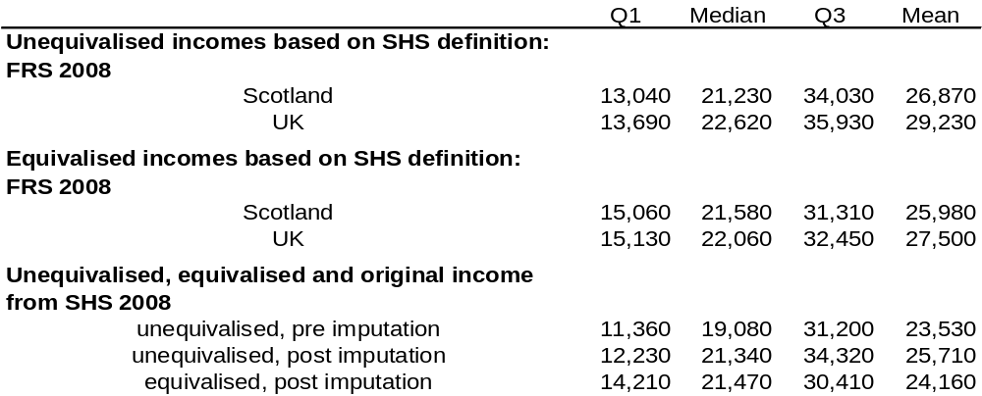

Impact of imputation for groups within Scotland
9. The following tables present some analysis of the impact of the imputation process on the SHS household income for groups within Scotland. The SHS median income before and after imputation is compared to the FRS median income. Table 2 below, does this for urban and rural areas, and areas which are deprived according to the SIMD. It shows that:
- For most areas the imputation process brings the equivalised and unequivalised SHS income closer to the FRS estimates.
- The exception to this is for small towns and rural areas where the pre-imputation unequivalised SHS income totals are closer to the FRS estimates than the FRS post imputation totals.
Table 2: Comparison of median Scottish incomes from the FRS and SHS before and after income imputation for "other adults" - deprived, urban and rural areas
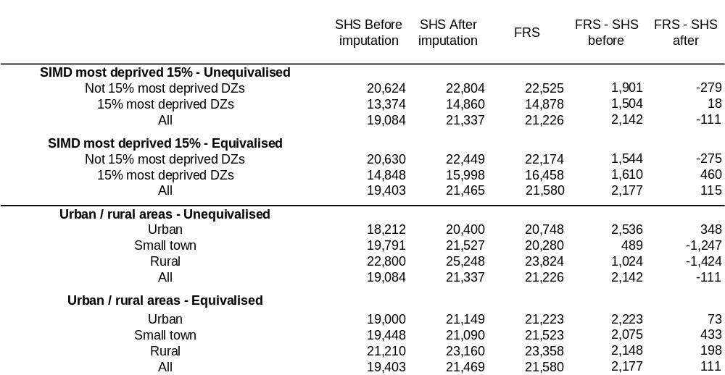

10. Table 3 compares the pre- and post- imputation SHS median incomes with the FRS median incomes for several household types. It shows that:
- Broadly speaking, the household types for which the imputation process brings the SHS estimates closer to the FRS are those which we would expect to be affected by the imputation process i.e. those which contain “other adults”.
- Income estimates for large family and large adult household types are significantly closer to the FRS income estimates after the imputation process.
- Household types which are less likely to contain “other adults” are less affected by the imputation and their income is generally closer to the FRS incomes to begin with.
- Income for pensioner households seems to be under-reported by the SHS relative to the FRS and this situation is not improved dramatically by the imputation process. This suggests that there is another issue, separate to the “other adults” issue affecting the incomes of these households in the SHS.
Table 3: Comparison of median Scottish incomes from the Family Resources Survey and Scottish Household Survey before and after income imputation for "other adults" - households containing different family types
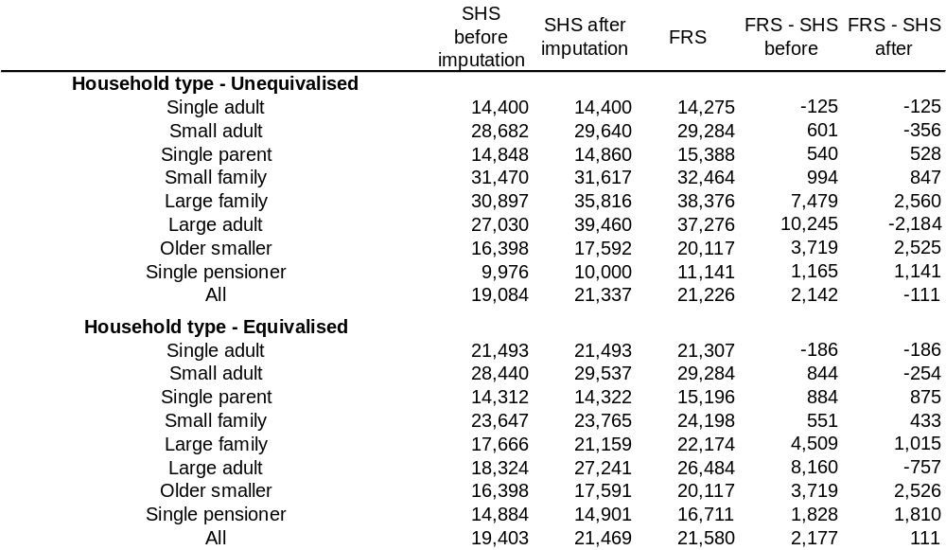

Impact of imputation on local authority estimates.
11. Table 4 is taken from the Ipsos MORI feasibility report and shows the degree to which household income increases across local authorities as a result of the income imputation.
- Across LAs the mean and median increases are 9 percent.
- North Lanarkshire, South Ayrshire and West Dunbartonshire were the LAs which saw the greatest percentage increase in their median incomes.
Table 4: Net household income before and after imputation of other adult’s income by local authority, SHS 2005-2006 (Ipsos MORI feasibility report - p44)
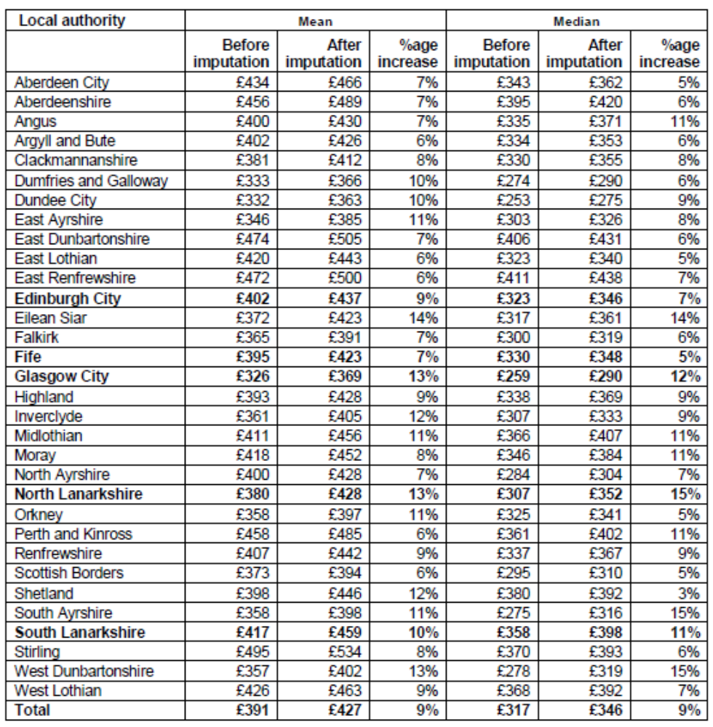

12. Ipsos MORI examined this as part of the feasibility study and concluded that:
“While in Fife, 15% of households contain ‘other adults’, in North Lanarkshire, 24% of households contain ‘other adults’. Households with three or more adults and no children – the household type where the inclusion of other adult income will have the most effect on household income – are also more prevalent in North Lanarkshire (10%) than in Fife (7%). Therefore, the difference in the impact of the additional imputation on North Lanarkshire and Fife is primarily due to differences in the distribution of household types. This again suggests that the imputation strategy is successfully reflecting differences between the local authorities.”
Q.2: Is the underlying SHS income data good enough to support detailed analysis of income?
13. The FRS is widely recognised as the best data source for poverty estimation and is used to monitor income and poverty at a UK and Scotland level. It contains detailed questions about household income and they are asked of all householders. The sample size in Scotland is sufficient to give poverty estimates for:
- Scotland as a whole;
- urban/rural;
- SIMD 15% most deprived areas;
but the sample is not large enough to support analysis by local authority.
14. The SHS has a much larger sample, around 28,000 for a two year sweep in Scotland, but records less detail on household income and doesn’t ask the income questions of all householders. The quality of the SHS income data has been examined a couple of times. Firstly in 2004, researchers commissioned by the then Scottish Executive and Communities Scotland compared the income data collected by the SHS with the income statistics produced from the FRS. Their main conclusions were:
- the SHS under-estimate total household income, due to collecting only the income of the highest income householder and any spouse/partner;
- when households with one adult or two adults who are spouses/partners are compared, there is good agreement between the SHS and FRS income distributions for such households;
- overall income from benefits agrees well between the surveys, but the individual benefits may be less accurately classified in the SHS.
Secondly the Ipsos MORI feasibility study compared the two sources and came up with similar conclusions (see paragraph 3 above).
15. However, despite both these investigations highlighting good agreement between the FRS and SHS, there are several reasons why SHS income data should not be used with the same confidence as the FRS data:
- Information is provided "off the top of the head" as part of an interview on many other topics. There is no requirement to refer to pay slips or bank statements to check the figures.
- Although overall income from benefits agrees well between the surveys, individual benefits may be less accurately classified in the SHS
- Over half of households in the SHS (53%) are unwilling or unable to provide complete income information and have some component of income imputed at the data processing stage of the survey. In total 30% of all income in the SHS is imputed. See table below for more detail.
Table 5 - Amount of income from different sources which is imputed in the SHS (£ billion): SHS 2009
 | Benefits | "Other" benefits | Misc Income | Earnings | Total income
Imputed | 3.2 | 0.9 | 1.2 | 10.6 | 15.8
Not imputed | 6.0 | 0.9 | 3.3 | 26.1 | 36.1
Total | 9.2 | 1.7 | 4.5 | 36.7 | 52.0
Percentage imputed | 35 | 50 | 27 | 29 | 30

16. This suggests that whilst we may get good overall estimates of household income from the SHS, because a significant level of income imputation has already taken place at the data processing stage, we should be cautious about using it for detailed analysis of income and if we try to drill down to the sources of income are we will quickly get into difficulty. Also the lack of accuracy on the benefits data recorded limits the analysis that can be done at the lower end of the income distribution. This is important to consider particularly when thinking of the secondary aim of the project listed in paragraph 2 above, which was to provide a source for more detailed analysis of the income distribution.
17. It is worth noting however, that because the imputation done at the data processing stage does not use the FRS, it does not undermine the ‘other householder’ imputation carried out for this project since it is drawing on the strength of the FRS rather than re-working already imputed SHS data.
Q.3: Is it reasonable to expect poverty to correlate closely with SIMD and other benefit based poverty proxies?
18. Comparisons with SIMD and child tax credit and benefit series do not show a close correlation with the SHS poverty estimates at local authority level, (see annex A, Figures 3 and 4). Since the SIMD income domain is often considered as a proxy for poverty at a local level and the child tax credit and benefit series is the proxy recommended for use in SOAs for monitoring child poverty, it is reasonable to ask why the patterns appear different across LAs. There are several points to consider here:
- The SIMD income domain is based on benefits and tax credits (Income Support, Job Seekers Allowance (JSA), the guarantee credit part of Pension Credit, and tax credits for some groups): not all households claiming those benefits are in poverty and not all households in poverty claim these benefits. For example: The Department for Work and Pensions (DWP) estimate that almost half of households with children claiming Income support are not in poverty and 55% of Working-age-adult households claiming IS are not in poverty. 43% of Working-age-adult households claiming JSA are not in poverty, and 32% of families with children. A more detailed look at the interaction between SIMD and poverty is given in Annex B.
- Figures 3 and 4 in Annex B show SIMD plotted against the SHS poverty estimates pre and post imputation. The correlation appears slightly better post imputation .
- The chart below shows the proportion of children, adults and pensioners in deprived areas according to SIMD 2009 v2 who are in relative poverty (before housing costs). It shows that whereas poor children and working age adults are more concentrated in deprived this is not true of pensioners. This suggests that SIMD is less effective at highlight concentrations of poor pensioners than it is for younger groups. Possible reasons for this include:
  - Pension credit being an effective benefit at lifting pensioners above the poverty threshold
  - Low take-up of pension credit among poor pensioners.
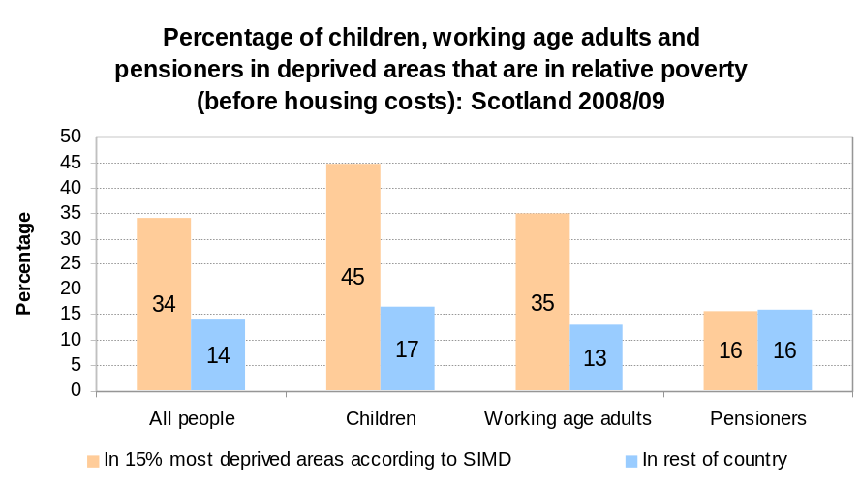

- Some concerns were raised about the relative ranking of LAs by their poverty rate (using the new SHS poverty estimate) compared with rankings by SIMD. This type of comparison can easily give rise to spurious results because many of the LAs have similar levels of poverty and benefit claimants and allocating a ranking does not reflect this. Also the confidence intervals that surround the poverty estimates overlap in many areas and because of this we shouldn’t really compare rankings in this way.
- Housing benefit may have an impact. Housing Benefit is included in household income for the measure of poverty used here. The impact of this on household incomes will vary across LAs and could contribute towards some of the differences when comparing with benefits claimant counts – further work could be done to look into this effect.
19. Glen Bramley’s paper, Benefit Take-up and the Geography of poverty in Scotland is an investigation into the limitations of benefit take-up as a measure of poverty and provides some interesting insights and shows that not all of those in or near to income poverty are covered by the benefits system, and the proportion not covered is relatively greater in more affluent areas. See Annex C for more detailed excepts from his paper.

Conclusions
20. In answer to the three questions set out in the introduction in paragraph 1, the evidence discussed in this paper shows:
- The imputation procedures look to be working reasonably well and the poverty estimates after imputation are closer to SIMD than pre-imputation.
- The SHS income shows good comparability with FRS, but the levels of incomplete income information means that there are limitations in what it is sensible to analyse.
- It’s reasonable to expect not too close an alignment between SIMD and poverty.
21. This suggests that the data and methods are good enough to publish Local Authority level poverty estimates but we should not be tempted to use it for more detailed analysis of the income distribution (that should remain the domain of the FRS).
22. The estimates are a useful addition to our knowledge of poverty at sub-Scotland level and could be used by Local Authorities alongside other indicators such as SIMD to give a broader picture of poverty. They are also potentially useful in increasing our understanding of rural poverty.

Income and Poverty Statistics Branch
Communities Analytical Services
28 February 2011

Annex A: Some interesting scatter plots about the imputation process
Figure 1: How does the imputation process affect the LA-level poverty rates?
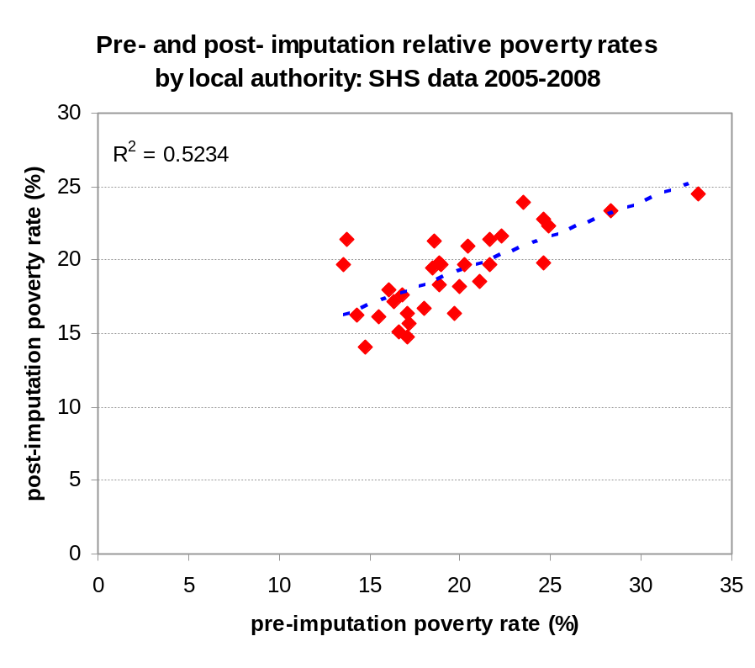
Figure 2: How does the imputation process affect the LA-level income estimates?
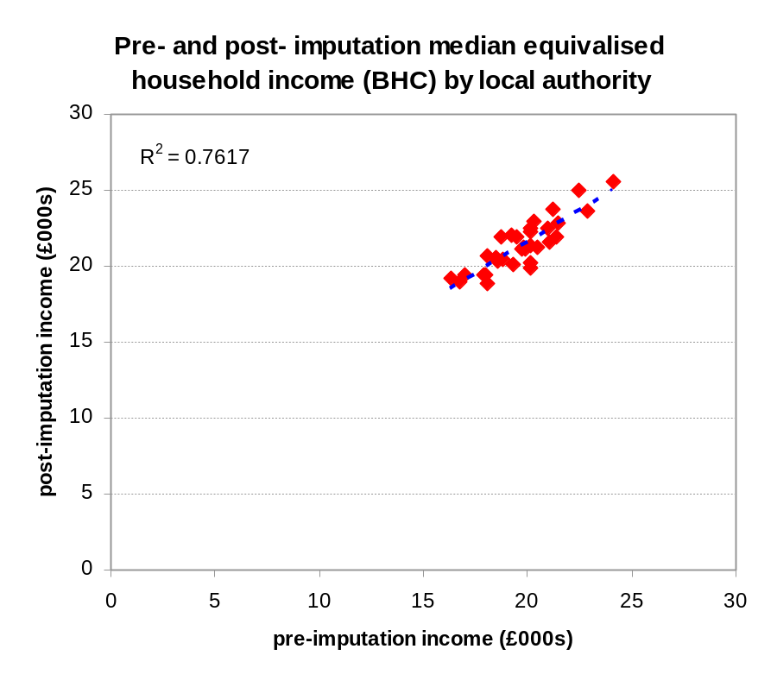
Figures 3 and 4: How do the pre- and post- imputation poverty rates compare to the SIMD Income deprivation figures?
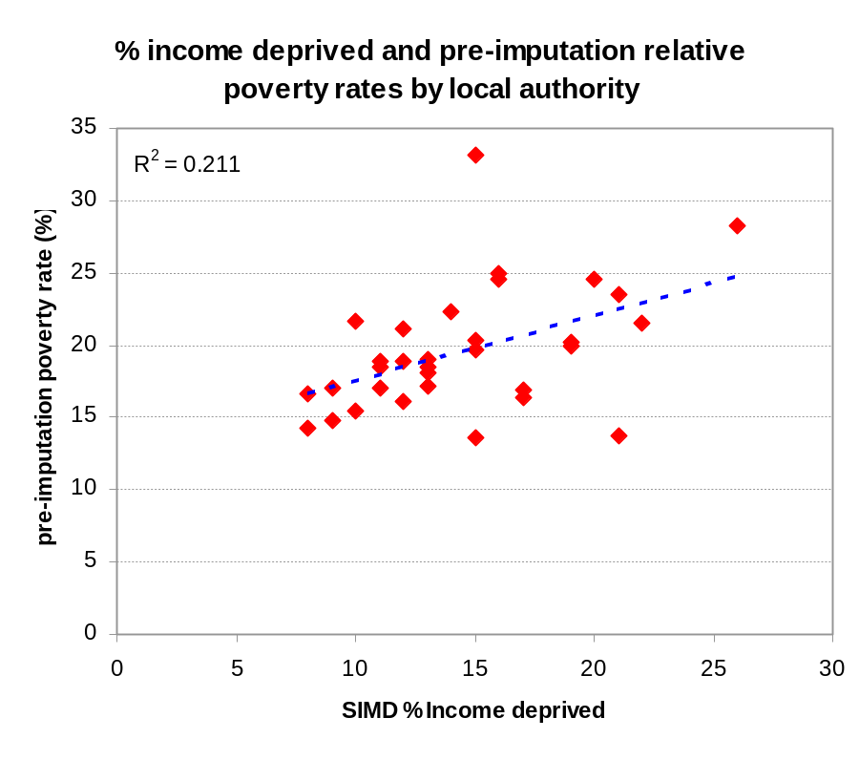
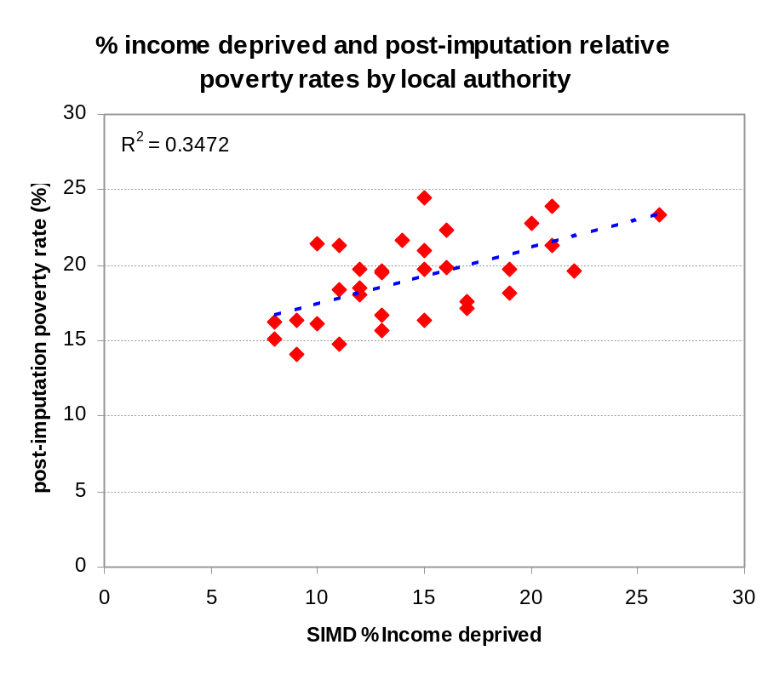

Annex B
The relationship between income deprivation and relative poverty (before housing costs)
Introduction
This note uses data from the Family Resources Survey (FRS) to examine the relationship between families which would be recorded as “income deprived” in the Scottish Index of Multiple deprivation (SIMD) and “in relative poverty before housing costs” in official poverty figures. The FRS is used to quantify the overlap between these two groups. It is worth bearing in mind that there are several reasons why we would not expect these two groups to overlap exactly:
- Low benefit take-up - Many people entitled to income related benefits do not claim them
- Low benefit reporting in FRS - Many people claiming benefits do not report this is in the FRS
- People may receive benefits and not be in relative poverty - For some families the receipt of benefits will lift the family above the poverty threshold.
- Differences between tax credit and FRS income definitions - there are several differences between the low income definition used by HMRC to determine the tax-credit part of the income deprivation definition and that used in the FRS to identify poor households.
Definitions
Relative poverty - Individuals living in households whose equivalised income is below 60% of UK median income in the same year. This is a measure of whether those in the lowest income households are keeping pace with the growth of incomes in the economy as a whole. In 2008/09 the relative poverty threshold for a couple with no children was an income of £244 per week from all sources (Income from all sources before housing costs and after income tax, national insurance etc…). For a couple with children the threshold would be higher and for a single person (without children) the threshold would be lower.
Income deprivation in the SIMD 2009 V2 is a count of:
- Number of Adults (aged 16-59) receiving Income Support (Department for Work and Pensions (DWP))
- Number of Adults (aged 60 plus) receiving Guaranteed Pension Credit (DWP)
- Number of Children (aged 0-15) dependent on a recipient of Income Support (DWP)
- Number of Adults receiving (all) Job Seekers Allowance (DWP)
- Number of Children (aged 0-15) dependent on a recipient of Job Seekers Allowance (all) (DWP)
- Number of Adults and Children in Tax Credit Families on incomes below £247 (HM Revenue and Customs)
Method
Using the variables in the FRS about the benefits received by families and their income levels we have created an “income deprivation” definition which attempts to replicate the SIMD definition as closely as possible. We define families as income deprived if they receive one of the benefits mentioned above and, in the case of families receiving tax credits, if they have incomes below £247.
Results
Table 1 shows that almost 600 thousand people in Scotland were income deprived according to the approximate FRS definition during 2008/09. This is 12 percent of the population which is lower than the SIMD 2009 estimate of 15 to 16 percent of the population income deprived. The qualifications above probably explain some of this difference and we should bear them in mind when examining the figures. Assuming that there is little bias to this under-count, these figures present useful information about the relationship between income deprivation and relative poverty. They suggest that although most income deprived people are towards the bottom of the income distribution there is a considerable mis-match between these two groups.
- The figures suggest that most income deprived people (61 percent) are in relative poverty (before housing costs) but that a substantial minority (39 percent) are not.
- Over half of those in relative poverty according to the FRS (58 percent) are not recorded as being income deprived.
Table 1: Income deprivation by poverty status: 2008-09
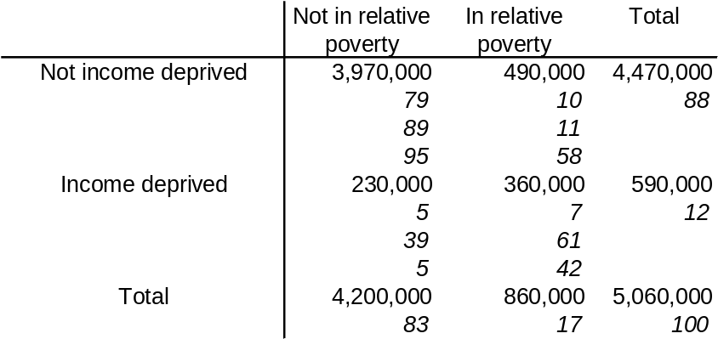
Note: Figures in cells are in the following order: Frequency, percent, row percent, column percent
Table 2 presents UK figures which show the percentage of income deprived people in each equivalised income decile. This shows that income deprived people are certainly grouped towards the bottom end of the income distribution although some are higher up, there are even a few in the top two deciles. The relative poverty threshold lies between the first and second deciles and, as table 1 shows, many income deprived people have income above this level.
Table 2: Percentage of income deprived by who are in each equivalised income decile: UK 2008-09
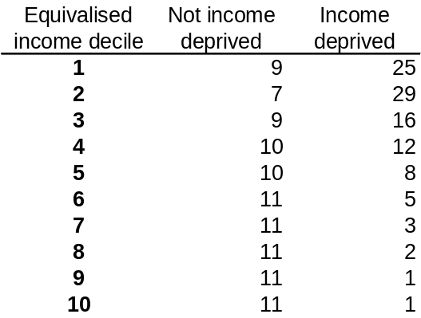

The following table (Table 3) breaks down the groups of people who are, and are not, in relative poverty and income deprivation by the economic status of the families that they live in. This enables us to look at the sort of families who are more likely to fall into one, but not the other, of these two groups.
- Families headed by a couple where both adults are working full-time, or where one works full-time and the other part-time are unlikely to be in relative poverty OR income deprivation.
- Families where the family head is unemployed make up a quarter of those in the “income deprived and in relative poverty” group and smaller proportions of those in the other groups. This suggests that for unemployed families the income deprivation indicator is particularly effective at picking those that are relative poverty.
- Pensioner families make up 2 percent of those in the “income deprived and in relative poverty” group and 33 percent of those in “NOT income deprived and in relative poverty” group. This suggests that there are many poor pensioners which are not picked up by the income deprived indicator. This could be an issue with the methodology used here as the guaranteed credit element of Pension Credit is not well reported in the FRS. It could also be an issue with the take-up of this benefit, or simply that this benefit is effective in lifting people above the poverty threshold.
Table 3: Percentage of income deprived by who are in each equivalised income decile: UK 2008-09
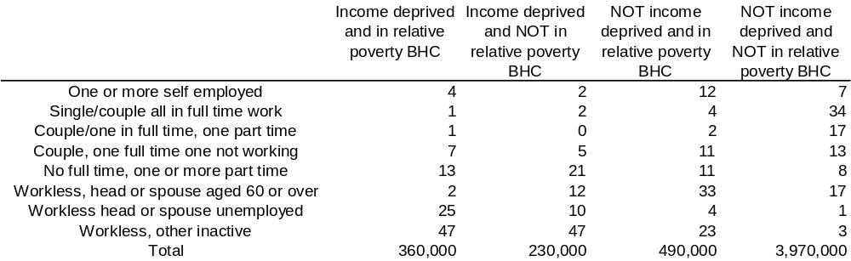

Tom Spencer
Communities ASD
February 2011
Annex C
Extracts from Glen Bramley’s paper: ‘Benefit Take-up and the Geography of poverty in Scotland’ Regional Studies, Vol. 34.6 pp. 507-519, 2000
Rural vs. urban areas: …this reflects, first, the concern that take-up of particular benefits may be systematically different (specifically, lower in rural areas), whether due to extra difficulty and higher cost of claiming benefits, or less information and advice being available, or cultural differences creating greater stigma in rural areas. Second, there is a concern that the nature of poverty may also be different in rural areas, associated with a greater degree of in-work poverty and a higher cost of living.
Affluent vs. poorer areas: …this also reflects provisional evidence that the take-up of benefits may systematically differ depending on the type of area in which households live, with the dimension of poor vs affluent being the most important systematic, overarching difference between local communities. Poverty and affluence is measured by the Breadline Britain index, interpreted as the percentage of households likely to be in poverty (lacking 3 or more ‘necessities of life’). This index, can be said to provide an objective classification of areas which is independent of the survey or benefits data being analysed in this study.
Elderly vs. non-elderly: …preliminary evidence suggests significantly different patterns of benefit claiming amongst the elderly and non-elderly households, whether because of different attitudes to claiming, because of different degrees or forms of entitlement, or because of differences in mechanisms by which potential claimants do or do not come into contact with the benefit system.
Income support: …Analysis showed a significant under-reporting of the receipt of IS among elderly people in the SHCS, even after reasonable imputation. There also seems to be a significant degree of under claiming. On average, a third or more of eligible elderly households do not claim IS in Scotland. Take-up ratios indicate there is a markedly lower IS take-up rate in affluent areas compared to less affluent in the case of elderly households. The influence of area affluence is more significant in reducing take-up than rurality. Non-take up of IS does not systematically differ by the affluence of the area for non-elderly households.
How far do benefits cover all of the poor? (This analysis will be out of date as because of developments in the benefit and tax credit system since 1999, but general observations may still be relevant): …There appears to be a greater underestimation of low income using benefits data in richer areas than in poorer areas and suggests some caution in the use of benefit measures in grant distribution formulae, particularly in services like those for the elderly.
..from the conclusions..
Not all of those in or near to income poverty are covered by the benefits system, and again the proportion not covered is relatively greater in more affluent areas.
It is possible to draw a profile of non-benefit income poor’. They include many elderly households and quite a few complex multi-adult households, but relatively few households with children. Their economic status is diverse with a significant minority in work as well as a large retired group, long term sick and students. Half or more are in private sector housing, in contrast with benefit receiving poor who are overwhelmingly concentrated in social housing.
The finding that there appears to be a greater underestimation of low income using benefit data in richer areas than in poorer areas is somewhat surprising….It suggests some caution in the use of benefit measures in grant distribution. Some explanations suggest a genuine danger of bias, of missing poverty in unexpected places: the fact that some benefits are mainly or exclusively associated with rented housing; the isolation of poor people in affluent areas – less info on benefits. Other explanations suggest that the apparent under-representation of poverty in affluent areas is more apparent than real. More of the low income households in these areas may be cash poor but asset rich.

www.scotland.gov.uk/SHS
www.scotland.gov.uk/Topics/Statistics/Browse/Social-Welfare/IncomePoverty/income-imputation-study6/income-imputation-pdf
www.scotland.gov.uk/Topics/Statistics/Browse/Social-Welfare/IncomePoverty/income-imputation-study6/SHS-income-imputation
www.scotland.gov.uk/Publications/2010/08/26155956
www.scotland.gov.uk/SIMD
www.scotland.gov.uk/Topics/Statistics/Browse/Social-Welfare/IncomePoverty/income-imputation-study6
SHS only records income from the Household Reference Person and spouse or partern, whereas the FRS records income from all household members.
Approximately 14,000 households and 12,000 adults on an annual basis
Equivalisation is an adjustment for family size made to household incomes so that meaningful comparisons of incomes between families of different sizes can be made.
As defined by the Scottish Government’s Urban Rural Classification: www.scotland.gov.uk/UrbanRural
http://www.scotland.gov.uk/Topics/Statistics/16002/SHSIncPaper
http://www.scotland.gov.uk/Publications/2009/08/SHSMethodology0708/Q/Page/7
http://statistics.dwp.gov.uk/asd/hbai/hbai_2009/pdf_files/full_hbai10.pdf (Tables 4.6 and 5.9)
Glen Bramley et al ‘Benefit Take-up and the Geography of poverty in Scotland’ Regional Studies, Vol. 34.6 pp. 507-519, 2000

